Sonarqube Github

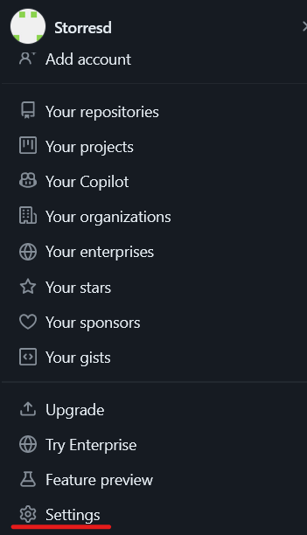

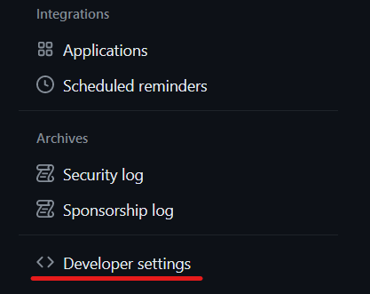



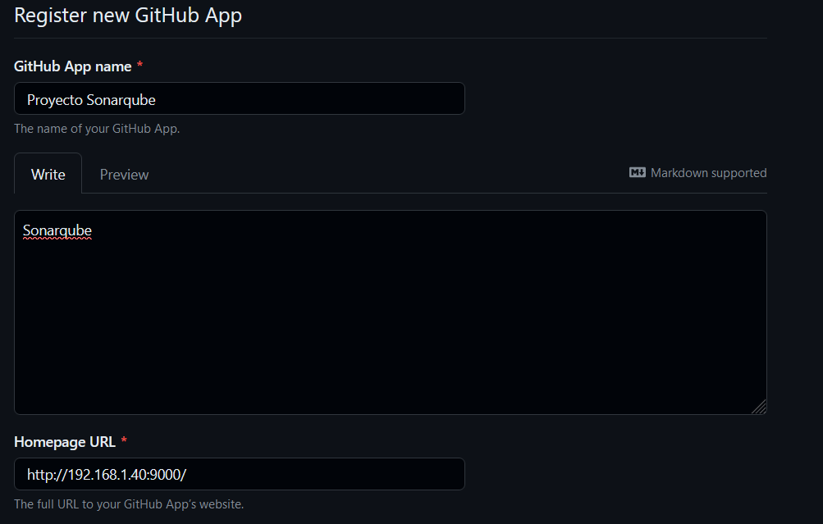



[Registering a GitHub App - GitHub Docs](https://docs.github.com/en/apps/creating-github-apps/registering-a-github-app/registering-a-github-app)